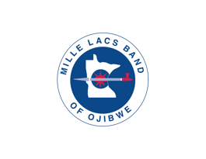
PHOTO/VIDEO CONSENT FORM

I, _________________________________________, hereby grant and authorize the Mille Lacs Band of Ojibwe and/or it’s authorized contractor(s) the right to take, edit, alter, copy, exhibit, publish, distribute and make use of any and all photos and/or video taken of me by the Mille Lacs Band of Ojibwe and/or it’s contractors to be used in and/or legally promotional materials including, but not limited to, newsletters, flyers, posters, brochures, advertisements, fundraising letters, annual reports, public service announcements, press kits and submissions to journalists, websites, social networking and media sites, and other print and digital communications, without payment or any other consideration. This authorization extends to all languages, media, formats and markets now known or hereafter devised. This authorization shall continue indefinitely, unless I otherwise revoke said authorization in writing.

I understand and agree that these materials shall become the property of the Mille Lacs Band of Ojibwe and will not be returned.

I hereby hold harmless, and release the Mille Lacs Band of Ojibwe and/or it’s contractors from all liability, petitions, and cause of action which I, my heirs, representatives, executors, administrators, or any other persons may make while acting on my behalf or on behalf of my estate.

_________________________________ (Print Full Legal Name)

_________________________________ (Signature)

_________________________________ (Date)

If the person signing this agreement is under the age of consent of 18 years old, then this release must be signed by a parent or guardian.

_________________________________ (Print Full Legal Name)

_________________________________ (Signature)

_________________________________ (Date)

