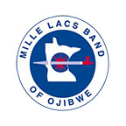

The Mille Lacs Band of Ojibwe Indians
Traditional Powwow

Royalty Contest
Information Packet
2021

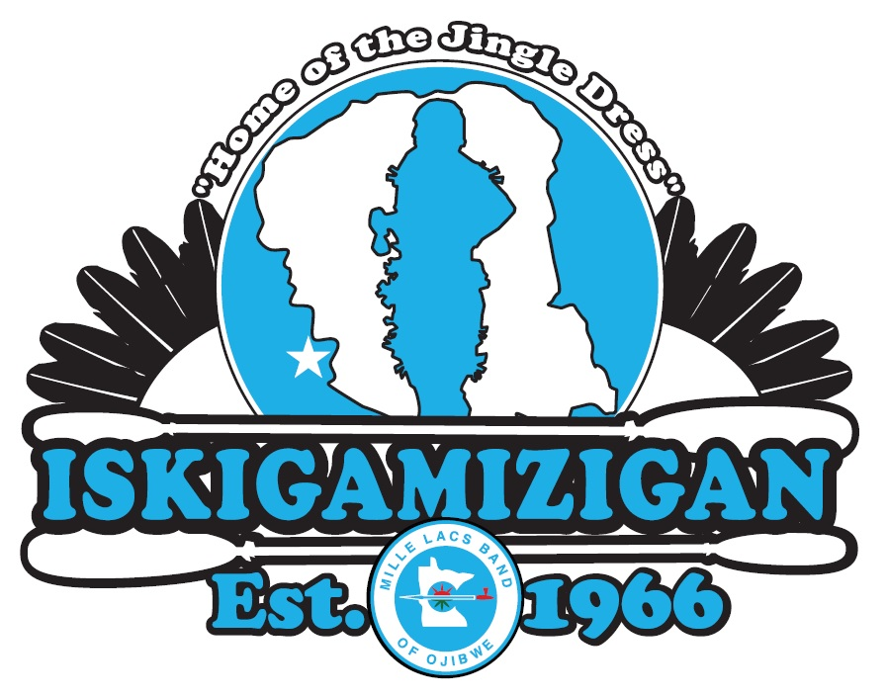

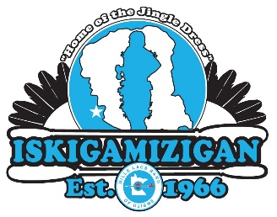

The Mille Lacs Band of Ojibwe Indians
Traditional Powwow

Royalty Contest 2021

Important Highlight

- Royalty Contestants do NOT sell raffle tickets

- DEADLINE: Must complete, sign and submit your Royalty Contestant Application no later than August 19, 2021. We strongly suggest registering as soon as possible, to give yourself more time to accumulate your hours required for cultural activities. No late applications accepted after August 20th.

- DEADLINE: No cultural verifications slip this year due to the Covid -19 Pandemic.

- Contestants must be in attendance for the entire Powwow, August 20 -22th, 2021.

- No Last-Minute Contestants – In Case of Certain Situation, we will consider it

If you have any questions, concerns or problems, please contact the Royalty Committee:
Sherry Pewaush 320-362-4857 or Deilyah Dexter 320-515-1378

Powwow Committee Officers:
- George Morrow, Co-Chair
715-558-3859
georgemorrow3@gmail.com
- Bobby Eagle, Co-Chair
218-454-8918
OgimaaGiniw42@gmail.com
- Christine Pewaush, Treasurer
218-513-5792
christine.pewaush@millelacsband.com
- Barb Martin, Secretary
218-251-7052
Barb.Martin@hhs.millelacsband-nsn.gov

We are Your Powwow Committee: Please feel free to openly engage the Powwow Committee Members. We also encourage you to attend regular Powwow Committee Meetings and give us your perspective. As you grow into young adults, you will see how important and rewarding it is to become involved with the community. Start young and learn how you can be an asset to your people. Someday you could be a Senator, Governor, President of the United States, or Chief Executive of the Non-Removable Mille Lacs Band of Chippewa Indians.

The Mille Lacs Band of Ojibwe Indians
Traditional Powwow

Royalty Contest 2021

Eligibility Requirements

The Royalty Sub-Committee will review all applications to determine eligibility of applicant to run as a Royalty contestant. Applicants will be notified of decision within 7 days or less of the Royalty Sub-Committee receiving a completed application. Eligibility requirements include:

- Enrolled Mille Lacs Band Member or Direct Descendant of a Mille Lacs Band Member

- Age Requirement:
- Jr. Brave/Jr. Princess - 6 to 12 years of age by Sunday Before Powwow weekend
- Sr. Brave/Sr. Princess - 13 to 18 years of age by Sunday Before Powwow weekend

- Must be currently attending/enrolled in school

- Must not be a parent or expecting a child during the contest and term of reign

- No Cohabitating

- Must represent the Mille Lacs Band as a positive role model for their peers by:
- Remain Drug and Alcohol Free,
- Have no involvement with negative or illegal activities
- Stay Law Abiding citizen
- Stay enrolled in school
- Serve as a positive role model to your peers.
- No Bullying

- Do not hold any other Royalty positions for the current year. MLB Traditional Powwow Royalty will be required to represent the MLB Traditional Powwow by wearing our crown and sash at all powwows and events you attend for the year. This will not allow you to represent any other entity during your reign.

- ** Mandatory Attendance: Reigning Royalty must attend Mille Lacs Band Powwows such as the Grand Celebration, the Traditional Powwow, Memorial Day Powwow, Gii-Ishkonigewg Powwow and the American Indian Month Powwow. Royalty are also expected to represent the Traditional Powwow at the Annual State of the Band Address. Full regalia is optional at non-powwow events but Royalty must wear their sash. Full Regalia, crown/roach and sash are to be worn at all powwows attended. Royalty can volunteer to represent the Traditional Powwow at other events, and may be requested to represent the Mille Lacs Band at various Band functions.

- Term Limits: In order to allow all Mille Lacs Band youth the opportunity to represent their community as Royalty, we have established a term limit. Reigning Royalty hold a 1-year term, steps down for 1-year at the end of their reign, before being eligible to run again.

The Mille Lacs Band of Ojibwe Indians
Traditional Powwow

Royalty Contest 2021

Point System & Categories

1. Public Speaking (50% of total points)

Sr Royalty Only - Based on Attendance, Ojibwe Language, and Clarity while presenting your version of “Why I want to represent the Mille Lacs Band as your Royalty...”

2. No Cultural Activities – Due to Covid-19 Pandemic

3. Dance (50% of total points)
- Points Based on Attendance, Dancing Aspects and Regalia Aspects.
- Contestants must attend all Grand Entries & Royalty Dance Specials
- Full Regalia worn throughout the entire four (4) sessions
- Sr. & Jr. Contestants must participate All weekend
  - Saturday has 2 dance Sessions afternoon & evening assigned by the Royalty Coordinator
  - Participation includes dancing and visible in the arena
- Only Exception to Attendance is dangerous/severe weather announced by committee

The Mille Lacs Band of Ojibwe Indians
Traditional Powwow

Royalty Contest 2021

Judge Selection

Judges are selected by the Royalty Coordinator, with an appropriate offering of tobacco before being asked. After the Royalty Registration is closed, the Royalty Coordinator will select five (5) Mille Lacs Band Members to serve as the main judges, and three (3) alternate judges, should one of the main judges be unable to complete their responsibilities. Criteria for judges include:

- one (1) judge from each Mille Lacs Band Community (District I, IIa, IIb, III and Urban)
- impartial with limited personal ties to the contestants
- immediate family members of any contestant are not eligible to serve as a judge
- an understanding of the Ojibwe Language
- an understanding of the various dance styles

Point Tally

Each Judge will rate each contestant throughout the weekend in the 4 Contest Categories. Upon completing the scoring of the contest, the Judges sign off on their scores and turns in their score sheets to the Royalty Coordinator. The 3 member Royalty Sub-Committee totals up the contestant scores with 3 scheduled employees coming in to confirm correct tally of the scores.

The Powwow Committee Employee Scheduler schedules three (3) Band employees, not related to any of the contestants. These 3 individuals verify the point count, and confirm the contestant with the winning points. The results of this 3 person verification will be the official record.

Once the winner is confirmed, the Royalty Coordinator will inform the Powwow Committee Officers and prepare for the Crowning.

The Crowning

The Royalty Coordinator and the current years Royalty shall be on hand for the crowning. The Royalty Coordinator shall direct the Arena Director to line the contestants in the arena, facing the emcee. The Royalty Coordinator shall give words of encouragement thanking each contestant for their hard work. The winners will be announced in the following order: Junior Princess, Junior Brave, and Senior Princess, than Senior Brave. Current Royalty will crown their successors. An Honor Song must follow the crowning, in honor of the exiting Royalty and the new Royalty. The families of both shall follow the Royalty out. Powwow Committee Members must be at the Royalty Crowning and follow behind the Royalty and family in the honor song.
**We must also provide time to thank the judges and present them with their gifts**
The Mille Lacs Band of Ojibwe Indians
Traditional Powwow

Royalty Contest 2021

Reigning Royalty Information

Royalty Specials: The Mille Lacs Band of Ojibwe’s traditions prohibit a blanket song or giveaways during the regular powwow schedule. Should reigning royalty wish to provide gifts, this activity must take place on Sunday before Noon (not during a regular session).

Travel:
The MLB Traditional Powwow Committee provides a $100 stipend per powwow, 6 times a year, to attend a Powwow that is more than 55 miles away from the student’s home district.

The Powwow Committee understands that family and Royalty may wish to attend an out of state powwow to gain the experience of different powwows throughout Indian Country. Unfortunately, the Powwow Committee is unable to financially support any additional travel beyond what is outlined above.

Requesting Travel Dollars:
Royalty must contact the Royalty Coordinator at least two weeks prior to the Powwow they are planning to attend. The Powwow Committee will not be held responsible for not providing travel money in time, if the request is not made at least two weeks in advance. Upon receiving the request, the Royalty Coordinator will immediately submit the travel request information to the Powwow Committee Treasurer. The Treasurer will submit a check request to OMB. We will attempt to provide the travel money in a timely manner, but this may be affected by unforeseen events experienced by OMB.

Right of Refusal: The Royalty Coordinator may refuse a request for travel dollars if travel dollars are low and may cause difficulty for that individual Royalty to attend mandated Powwows in the future. This situation will be discussed with the individual Royalty and their family. If the Royalty Coordinator does refuse a request, and the request was made with a two week notice, and the student has ample dollar amounts in their travel account, they can appeal the decision to the full Powwow Committee, by contacting one of the Powwow Committee Officers. During the Committee recess, the previous year’s Co-Chairs will be the deciding voice on travel issues.

Princess Crowns: The Jr. and Sr. Princess Crowns are provided each year by the Powwow Committee. At the end of your reign, these crowns are for them to keep. Each reigning Royalty is responsible for the care and safe keeping of these crowns; proper handling as well as proper and secure storage.

Brave Roaches: The Jr. and Sr. Brave Roaches are provided each year by the Powwow Committee. At the end of your reign, these roaches are for them to Keep. Each reigning Royalty is responsible for the care and safe keeping of these roaches; proper handling as well as proper and secure storage. In addition, the Jr. & Sr. Brave are authorized to attach their own headband to the roach, but must remove it before returning it at the end of your reign, and must take care not to damage the structure of the roach.

Sashes: The Royalty Sashes are provided each year by the Powwow Committee. Royalty is able to keep their sash at the end of their reign.

Positive Role Model:
Mille Lacs Band of Ojibwe Traditional Powwow Royalty is expected to be role models to their peers. As such the following behavior is outlined and failure to adhere to this will result in loss of title and the runner up being awarded the title.
- DRUG/ALCOHOL FREE: must abstain from all substance abuse/use during their reign.
- EDUCATION: the foundation for a successful and positive life style; Royalty shall not drop out of school.
- PERSONAL LIFESTYLE: The Powwow Committee recognizes the development of safe and responsible partnerships. The Powwow Committee stresses that questions of partnership are a natural part of growing up. It is important and we encourage the royalty to share these growing questions with your parent/guardian, elder, Weh-Ah or another influential adult to address these questions. However, as a positive role model to your peers, the Royalty title will be surrendered should the Brave or Princess become a parent during their reign.
- RESPECTING DIFFERENCES/RESPECTING LAW: Reigning Royalty is expected to show the proper respect to all they encounter during their reign. Be open minded when meeting people different from you, appreciate other’s culture, other’s history. Royalty are expected to follow the law. Discrimination based upon color, religion, sex, ethnicity, age, height, or weight is not acceptable. Intolerance and/or violation of any law are sufficient reasons to surrender the title.
In addition: Reigning Royalty are encouraged to build upon the relationships created as a contestant; CONTINUED LEARNING about who we are as a people, our language, our traditions, our culture. What does be Anishinaabe mean is extremely important. Go to Ceremonial Dances, ask your Elders questions, continue to be proud, and to be Anishinaabe!

Donations: Any donation received that is expressed for “Mille Lacs Band Royalty”, “Traditional Powwow Royalty”, “Senior Brave”, “Senior Princess”, “Junior Brave”, “Junior Princess”, “Mille Lacs Band of Ojibwe”, “Mille Lacs Band of Chippewa”, or any other formal title of the Powwow or the Band, must be surrendered to the Powwow Committee Treasurer. All funds donated are to benefit all four Royalty Students, regardless if the donation is given to one particular student, parent, or guardian. When donations are given privately the parent/guardian is obligated to inform the donator that the donation will benefit one student. When the donator does understand the donation is given to one specific person, then it may be used for the student the donation is solely intended for.

The Powwow Committee urges Royalty Families against solicitation of monetary donations from local businesses. Some local business may choose to only donate once and it is not fair to the committee or the other reigning royalty when monetary donations are exhausted for the sole benefit of one student. Royalty Families are asked to allow the Powwow Committee to solicit for monetary donations.

Fundraising: The Powwow Committee encourages each reigning royalty student and their families to engage in fundraising efforts to attend various powwows throughout their reign. Fundraising teaches the student responsibility and how to work towards achieving a goal they have set for themselves. However you need to be aware of what you can and cannot do during these fundraisers:

- Powwow Committee Sponsored Fundraiser -The Royalty Coordinator in consultation with the Powwow Committee will work with the reigning royalty and their families to provide assistance for a minimum of three (3) Powwow Committee Fundraisers throughout the reign. Powwow Committee will solicit for donations, advertise on the royalty’s behalf, and use of the name Mille Lacs Band of Ojibwe Powwow Committee and the Powwow’s Official Seal. When the committee sponsors a fundraiser, regardless of each families involvement, any monies generated will benefit all four (4) reigning royalty.
- Non-Powwow Committee Fundraiser -Each royalty family may fundraise without the Powwow Committee’s involvement, in those instances; monies generated will be used at the host families’ discretion. In private fundraisers the following phrases must be on the flier “help send”, or “support”, or “assist”, that reigning royalty’s name(s). The titles, “Mille Lacs Band Traditional Powwow” or “Mille Lacs Band Royalty” cannot be used on the flier. Those phrases suggest the involvement of the Powwow Committee and may also suggest the monies generated benefit each royalty student. The Traditional Powwow Seal may not be used during a private fundraiser. Powwow Committee Members may assist at private fundraisers; however, they cannot identify themselves as Powwow Committee. Co-Chairs, Secretary, and Treasurer should use their own discretion should they choose to assist; however, each officer is the face of the Traditional Powwow Committee and must ensure they do not give the impression of a committee event.
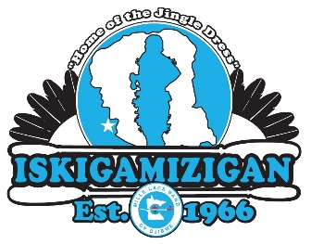
The Mille Lacs Band of Ojibwe Indians
Traditional Powwow

Royalty Contest Application - 2021

Contestant Name ______ ____ __SR/JR Brave __SR/JR Princess

Parent(s) Guardian Name

Address: City Zip:

Home Phone Cell Phone___________________________

Message Phone Email: _______________________________

In case of emergency contact:

Contestant Information:

Birth Date __ / / Style of Dance___________________

School Enrolled In ___________________________________________________

Are you a parent or currently expecting a child? ___Yes ___No

Are you Drug & Alcohol Free? ___Yes ___No

I have read the eligibility requirements set forth for the Mille Lacs Band of Ojibwe Traditional Powwow Royalty Contest. I understand and agree to follow all rules to remain eligible. I agree that if I am unable to maintain the standards of conduct throughout the contest and, if chosen, my reign, I may lose my eligibility/my title. I further agree to represent the Mille Lacs Band as a positive role model and maintain the standards of conduct to the best of my ability.

* If at any time you are struggling with keeping your commitment or if you are questioning if you should forfeit your title, please address these concerns with committee spiritual advisor Joe Nayquonabe

______
(Contestant Signature) Date

______
(Parent/Guardian Signature if Contestant is under 18) Date

Return this completed application to: Sherry Pewaush: 320-362-4857 sherpewaush@gmail.com

Address: 43408 Oodena Drive, Onamia MN 56359

